**High Confidence Mo/Si Multilayer Deposition for the Transmission X-Ray Multilayer Mirror Microscope TXM3**

Tetsuo Harada, Tadashi Hatano, Masaki Yamamoto

Division of Soft X-Ray Microscopy, Center for Advanced Microscopy and Spectroscopy,

Institute of Multidisciplinary Research for Advanced Materials, Tohoku University

E-mail: t-harada@tagen.tohoku.ac.jp

We have developed multilayer imaging mirrors for a transmission X-ray multilayer mirror microscope (TXM3) equipped with an LPP light source. The optics of TXM3 is　composed of four spherical multilayer mirrors, two for the Schwarzschild optics, and the other for illuminator optics. The throughput depends on a single multilayer reflectivity and reflection wavelength matching of the four multilayers. We have reported about our IBS deposition system with a moving deposition shutter (MDS) to control the period thickness distribution, as well as the deposition rate stabilization technique [1]. In this paper, we report the results of Mo/Si multilayer deposition on the four mirrors.

Figure 1(a) shows the period-thickness distributions of the spherical substrates used for TXM3. The dash-dot curves show the distributions without MDS control. Solid curves show those determined by the optical design, which should be targets of MDS control. In particular, the convex mirror (#1) in Schwarzschild optics requires a steep gradient. Figure 1(b) shows the period-thickness distribution of the deposited Mo/Si multilayer, which were measured by a reflectometer at Photon Factory BL-12A. The vertical axis is the period thickness difference from the design. All the errors were well controlled within ±0.6% that indicates the total throughput should be no less than 86% of the perfectly matched multilayers. The matching accuracy of #2-#4 is ±0.2%, enough to be applied to shorter wavelength multilayers such as carbon- and water-windows multilayers.

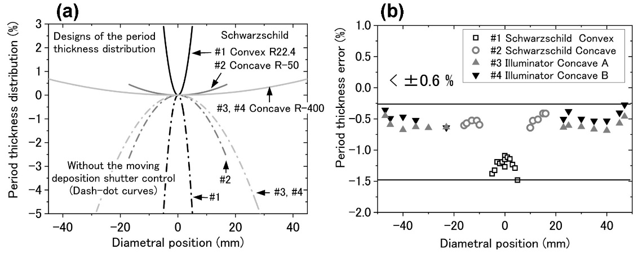

Figure 1. Period thickness distributions of (a) the design (solid curves) and those without the MDS control (dash-dot curves), and (b) experimental result of the four Mo/Si multilayer mirrors of TXM3.

**References**

[1] T. Hatano, H. Umetsu and M. Yamamoto, JSPE Publication Series, **3** (1999) 292.